c.v.

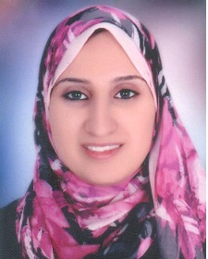
Personal Data

Name: | Maha MohamedSamy mohamoud
Date and Place of Birth: | 11/2/1992, Assiut-Egypt
Nationality: | Egyptian
Institute: | Chemistry Department, Faculty of Science, Assiut University, Assuit, 71516 Egypt
Telephone: | 00201093329868 (Mobil)
Current Position: | Demonstrator
Marital status: | Married
Fields of Research: | Physical Chemistry
E-mail: | maha.mohamed2013@science.au.edu.eg

Education and Academic Qualifications:

2013 : Bachelor of Chemistry, Faculty of Science, Assiut University, Very good with honour grade .
2014 until present: Demonstrator, Chemistry Department, Faculty of Science, Assiut University.

